**Q1:** Distance

The archer is located at position A (8, 4) and his target is at position T (2, 1). The archer can only fire an arrow 10 units. In this case will the archer hit his target? How far are A and T apart?

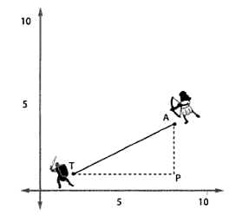

**Q2:** Vectors

I apologise to the ladies in the class. Please substitute Brad Pitt for Cameron Diaz! Or not, as the case may be.

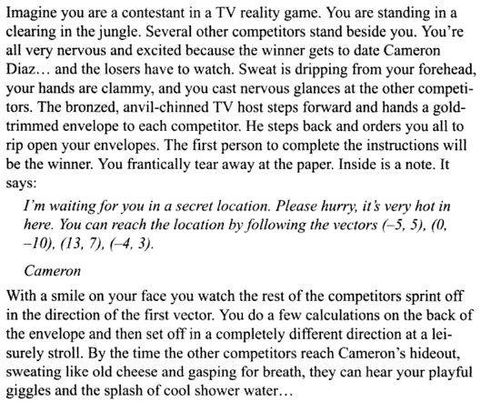

Plot on a graph the path you would take (assume you start at a position (0,0) ).

**Q3:** Vectors

Draw on a graph and then normalise the vector v (4, 5).

**Q4:** Vectors

Eric the Troll stands at position T (the origin) and is facing in the direction given by the **normalised** vector H (for heading). He smells fresh meat at position P and needs to figure out how many **degrees** he must rotate in order to face her.

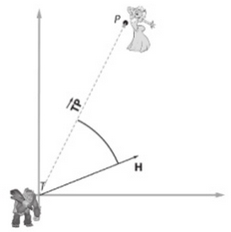

You need to use the dot product with the angle, and then isolate the angle in the equation.

You will need a calculator.

**Note:** For two 2D vectors a and b: a·b = |a||b|cos(Θ)

The coordinates for T are (0, 0)

The coordinates for H are (1, 0)

The coordinates for P are (4, 5)